Session 15

Assignment 1 Questions

*Session 15: Assignment 1*

**Table of Contents**

1. Introduction

2. Problem Statement

3. Output

**1. Introduction**

This assignment will help you to consolidate the concepts learnt in the session.

**2. Problem Statement**

1.Write a simple program to show inheritance in scala.

2.Write a simple program to show multiple inheritance in scala.

**3. Output**

Code and Output screenshot(s).

1.Write a simple program to show inheritance in scala.

**package** inheritance

**class** Employee {

**var** salary : Float = 1000

}

**class** programmer **extends** Employee {

**var** variablePay = 5000

println("satary:" + salary)

println("variable pay:" + variablePay )

}

**object** inheritenceobject {

**def** main(args:Array[String])

{

**new** programmer()

}

}

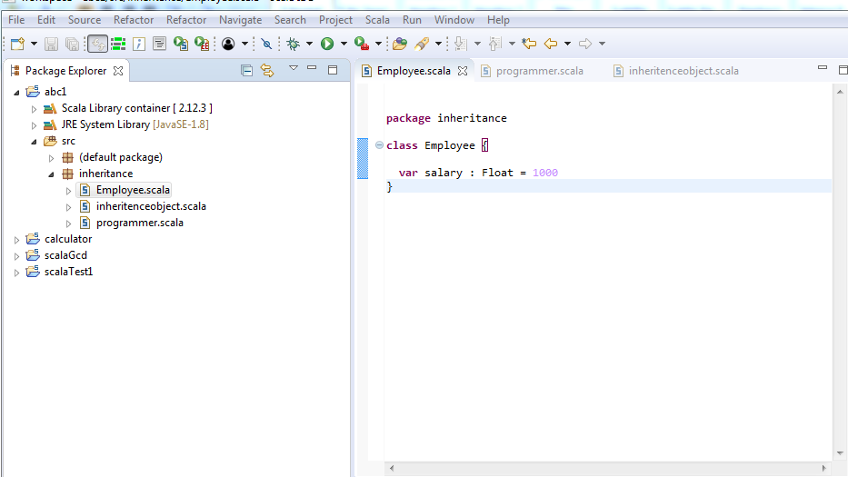

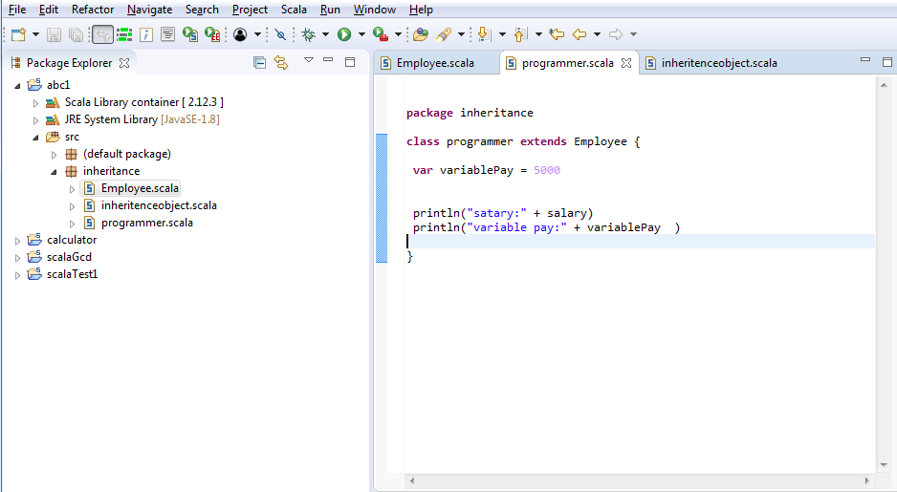

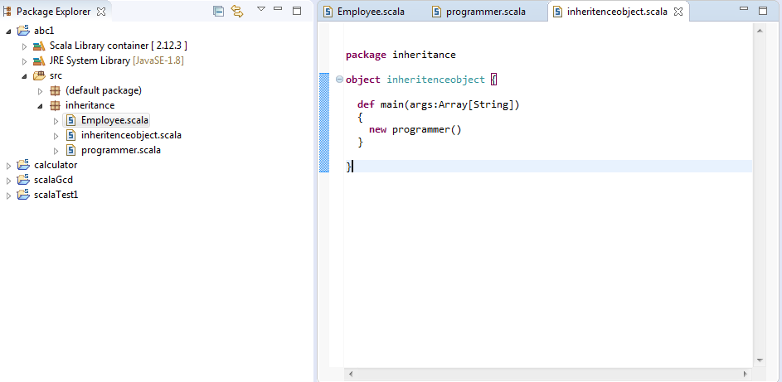

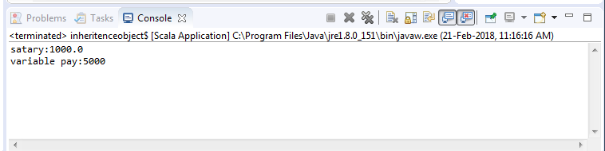

2.Write a simple program to show multiple inheritance in scala.

